Existco
Plant Control System

System Overview
With Traceability Focus

Table of Content
Contents
1. System Overview 3
2. Core Features 4
3. System Components 6
3.1 Purchase Orders / Goods Received 6
3.2 Production Consumption 8
3.3 Inventory 9
3.4 Production 11
3.5 Order Picking 14
4. Appendixes 17
Appendix A – GS1-128 System and Barcodes 17

System Overview

The Existco Plant Control System is an all in One Solution for Any production environment with interfacing to accounting system for the purpose of Sales / Purchases and Inventory.

Existco Plant Control System is well suitable and implemented in the Meat, Poultry, Seafood, Fruit and Veg, and General Food Manufacturing and Value adding, as well as general manufacturing.

Existco Plant Control System has all the relevant industry accreditations, From GS1, NMI, AUS Meat, MSA, AQIS (export Ready), NLIS, etc.

Below is a Block Diagram of the System and the Key processes in it.

Core Features

- Purchase Orders
  - Purchasing with Goods Received
  - Suppliers Purchase orders with Goods Received process using touch screen with scanner, scales, printers, Mobile Computer scanning, and Back office operations.
- Production
  - Interface to Production Equipment – Wedderburn Digi.
  - Touch screen Water Proof Solutions
  - Ability to connect to 2 scales, Wireless Industrial Barcode Scanner, Multiple Label and/or Tag Printers,
  - Multipurpose Touch screen.
  - Production planning based on sales, Min/Max Levels, and forecasting.
  - Recipe control and traceability.
- Traceability
  - Extensive information collected against each production transaction like Production Date & Time, Expiry Date, Operator, Product, Grade, Customer Order, Supplier of Raw Materials, etc.
  - Ability to recall quickly all production goods and get a customer list with detailed information.
- Batching
  - Grouping of production against batches with extensive additional data collected against the batch.
- Yielding
  - Yielding of Carcass Boning or any production processes that has an input and an output.
  - Yielding on any Production processes.
- Palletising
  - Extensive palletising capabilities with multiple storage locations.
  - Cold Storage management capabilities.
- Live Inventory
  - Every transaction is logged with date, time, Expiry, Specie, operators, batch, product, Grade, Station No, Pieces, Weight, Count, Price, etc.
- Stock taking
  - Extensive Mobility including smart stock taking, including ability to do Revolving stock taking.
- Triple Dimension Inventory
  - QTY and Weight, how many Cartons or Packets and what is the Weight for them.
  - Almost all systems are single dimension single quantity visibility, our solution as built from the ground up to be dual dimension inventory.
- Sales
  - Call Centre Capabilities to Chase customers for Orders. CRM Capabilities.
  - Customer Orders Importing
  - Mobile App for Sales Rep and Customers
  - Customer Web Ordering Portal
- Accounting ERP system Interface
  - Interface to Most Common Accounting System: Xero, MYOB On Premises & Cloud, MYOB EXO, Reckon on Premises & Cloud, QuickBooks Online, Attaché, Sybiz, Sage, SAP, etc.
  - Exporting of Sales, Purchases, POS Daily Sales Takings, GL Account of Stock on Hand.
- Order Fulfilment
  - Picking and packing with labelling
  - Special Customer Reequipments electronic fulfilment
- Proof of Delivery
  - Sign on glass, Delivery Management.
  - Truck Run Management.
- POS
  - Point Of Sales with all standard peripherals - Touch Screen PC, Receipt Printer, Barcode Scanner, Scale, Cash Drawer, Customer Display.
  - Butcher Shop (Hot Cashier).

- Mobility
  - Capabilities with wireless Mobile Computers for Mobile Operations.
- Web cart
  - Interface to Shopping Carts – Shopify, WooCommerce, Magento.
- Reporting
  - Extensive Reporting and Analysis, Business Intelligence – Microsoft PowerBI.
  - Dashboards, Reporting, with scheduled emails with reports.
  - Mobile Microsoft PowerBI client for Phone, Tablet, PC.
- EDI – Electronic Data Interchange
  - Interface to Coles / Woolworth / Metcash Ordering Portals.
  - Interface to other industry systems like, BuyLink, Spotless, Coupa, etc.

Industry Specific Features – Meat / Poultry / Seafood / Fruit and Veg
- Multi specie
- Kill Room Module – Extensive Kill Room Operations with NLIS Compliance, Carcass delivery.
- MSA Grading – Compliant and approved MSA Grading with Wireless Mobile Computers.
- Boning Room– Extensive Boning Room Operations with AusMeat Compliancy.
- Batch Boning Capabilities.
- Service Boning Capabilities.
- Sub Operations Capabilities.
- Food Service Order and Fulfilment capabilities.
- MSA Grading Compliant and Accredited.
- NMI Compliant and Accredited.

Accreditation
- NMI Accredited for POS and handling Weights.
- Export Accredited Tier 1 and Tier 2.
- MSA Grading Accredited.
- GS1 Partner, compliant and Accredited.
- POS - LoyaltyApp Accredited.
- POS – AfterPay / Zip Pay Accredited.

System Components

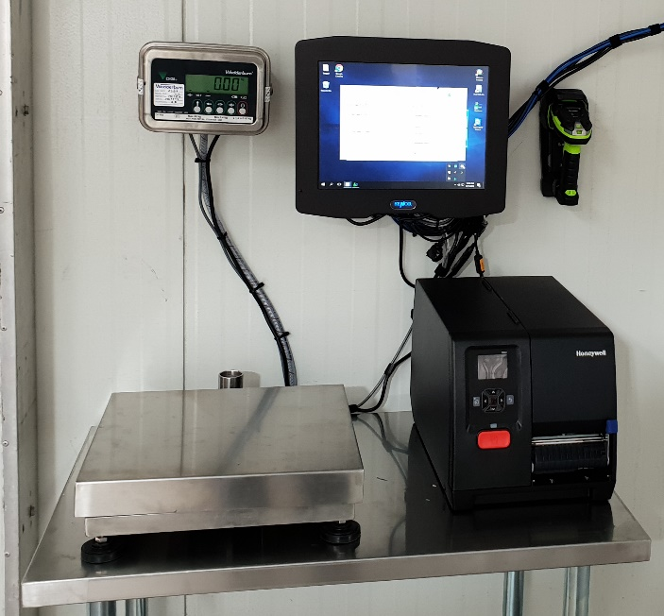
3.1 Purchase Orders / Goods Received

The Plant Control System has an extensive feature for purchase orders with goods received capabilities.

Purchase orders can be entered at the office and received in the receival area using the system touch screen and scanner or using the mobile Computer wirelessly.

The Fixed Mount Touch screen Receival station uses a touch screen, label printer, scanner and pallet scale.

The Receivable station can receive goods ordered, record batch numbers or create batch numbers, then print labels with 2D barcode on it with unique serial number in Industry standard GS1-128 barcode. (See Appendix A relating to GS1-128 Barcodes).

The Operator can Weigh using Pallet Scale, or scan Supplier Barcode (If GS1-128 Compliant) or manual enter the Quantity and Weight to the purchase order and print labels in the process.
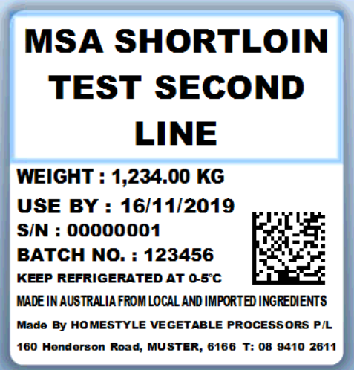
These labels can then be used to consume the stock to the production process.

An example of this label is seen on the right, and it is a GS1-128 compliant barcode and label format.

Each Label has a unique serial number batch number Weight, Quantity, Temperature, and many more attributes stored against it for full traceability requirements.

Below is an example of the Purchase Order Goods received Process.
The user can select the supplier, see all open Purchase orders for that supplier, then select the correct order he wants to receive.
Batch number recording or creation, Temperature, Production date, Expiry Date, pieces, Quantity Weight, Tare are all recorded per item received.
The Operator can also create a Purchase order on the fly if he does not have one already in the system and the goods just arrived.
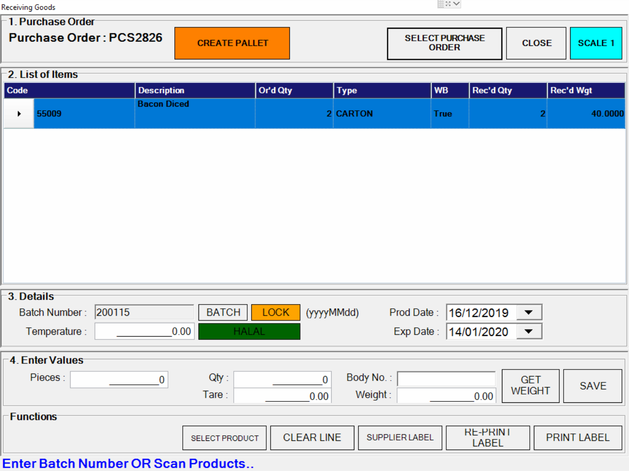

3.2 Production Consumption
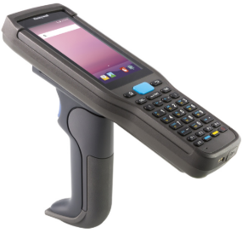
The Plant Control System records and maintains all the raw material inventory products that have been consumed to production, and capturing Date, Time, Operator, Production Area.

This process can be done with the Mobile Computers or the Touch screens.

A picture of the mobile computer seen on the right.

Each Touch screen and mobile computer is multipurpose that can perform multiple operations.

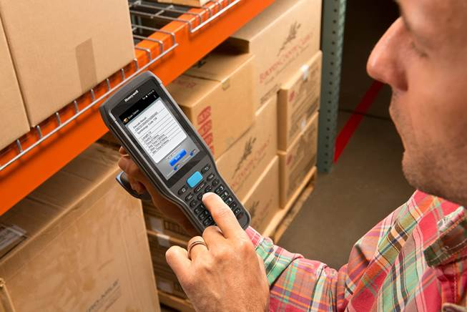

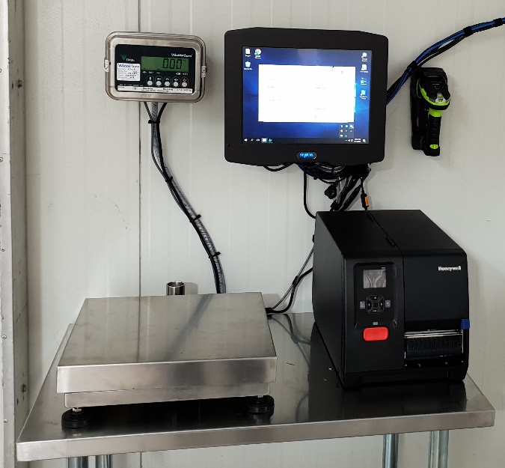

3.3 Inventory

The Plant Control System records and maintains a very detailed information of the inventory and this is done in 2 parts.

The first Part the system maintains current QTY and Wright Per Products as per screens hot below.

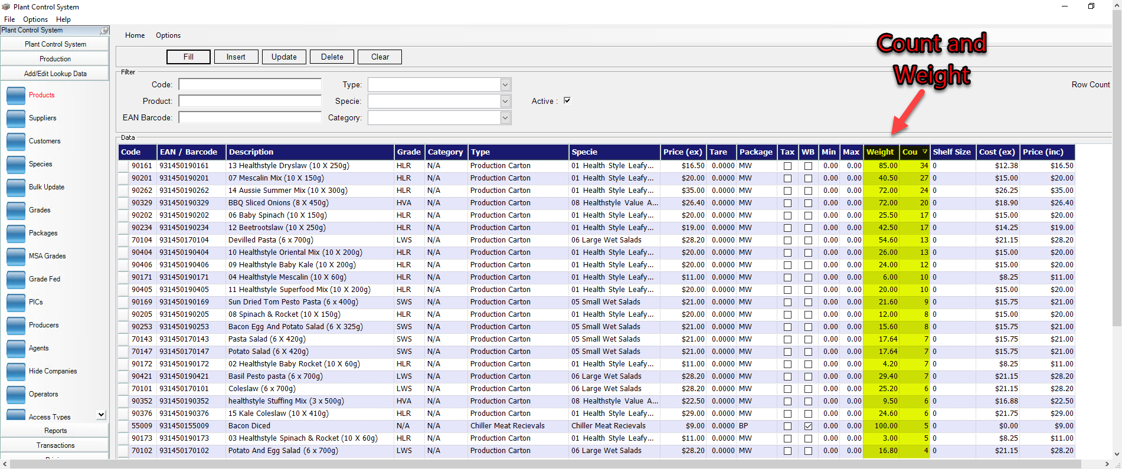
The second Part to the inventory management is each carton ever produced or received has a unique transaction in the system with all possible details relating to it as per screen shot below.
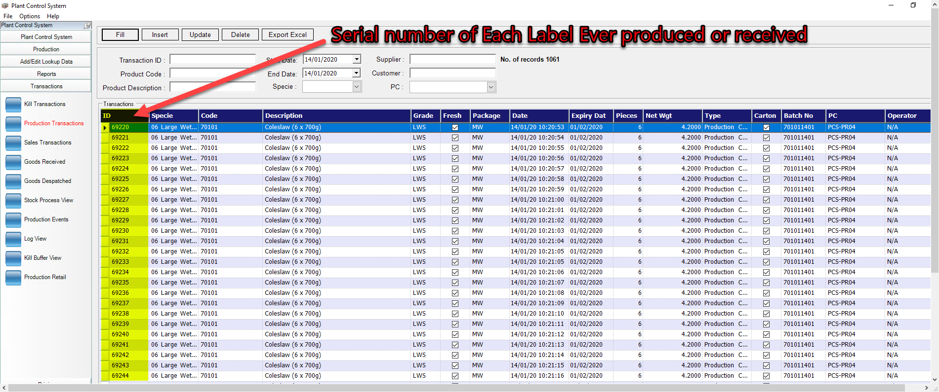

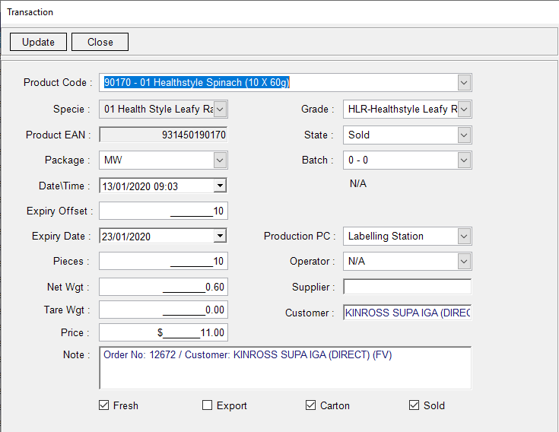
The following screen below shows all the details we record against each label ever produced.

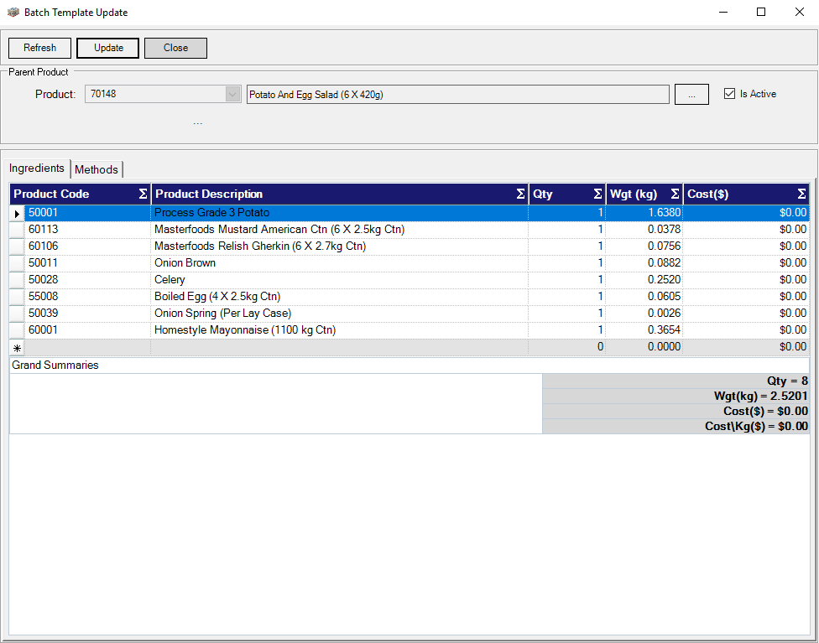
The system also maintains Product build (Recipes) for Products that have value adding and ingredients as per example on the right.

This information is then used on the production floor to guide the production on what to use when creating the products and record all items serial numbers and batches to maintain full traceability in the process.

3.4 Production

The Plant Control System uses Touch screen and printers and scanners and built in Logic to present the right information to the user to do his job properly preventing data entry error and mistakes in the process.

Below is a screenshot of the Generic Production To stock screen with batching capabilities.

Every label produced is incrementing stock on hand and creating a serial transaction for theta unique products with multiple attributes stored against it.

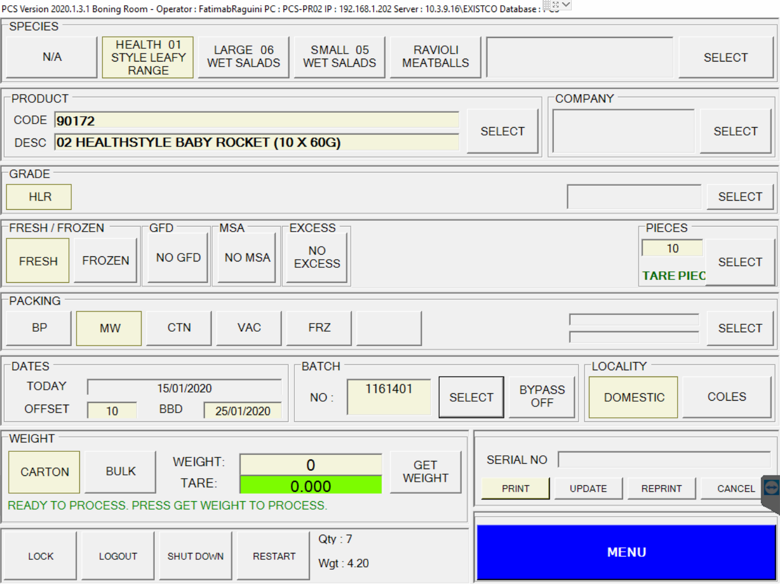

Below is a screenshot of the Production planning based on Min/Max level logic for different days of the week, as well as based on orders received to be fulfilled on the day.

This is the fundamentals of Just in time manufacturing, keeping stock very low only based on orders, forecasting, and managing the whole supply chain based on these demand and requirements.

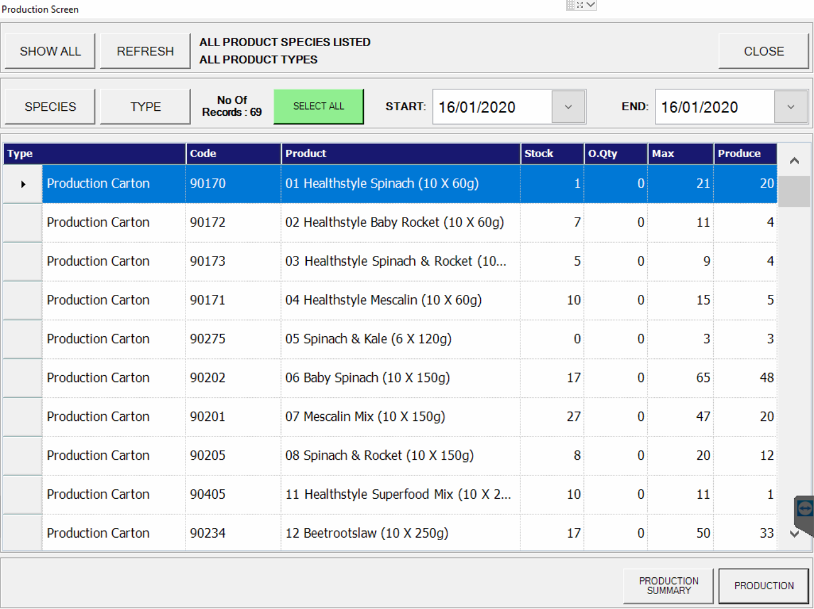

Below is a screenshot of the Bulk Production mode based on the previous planning that is on Min/Max level logic for different days of the week, as well as based on orders received to be fulfilled on the day.

This screen is used when doing a production run for a specific product an in this example they produce 20 Cartons of Product 90170 - 01 Healthy Spinach (1 0X 60g).

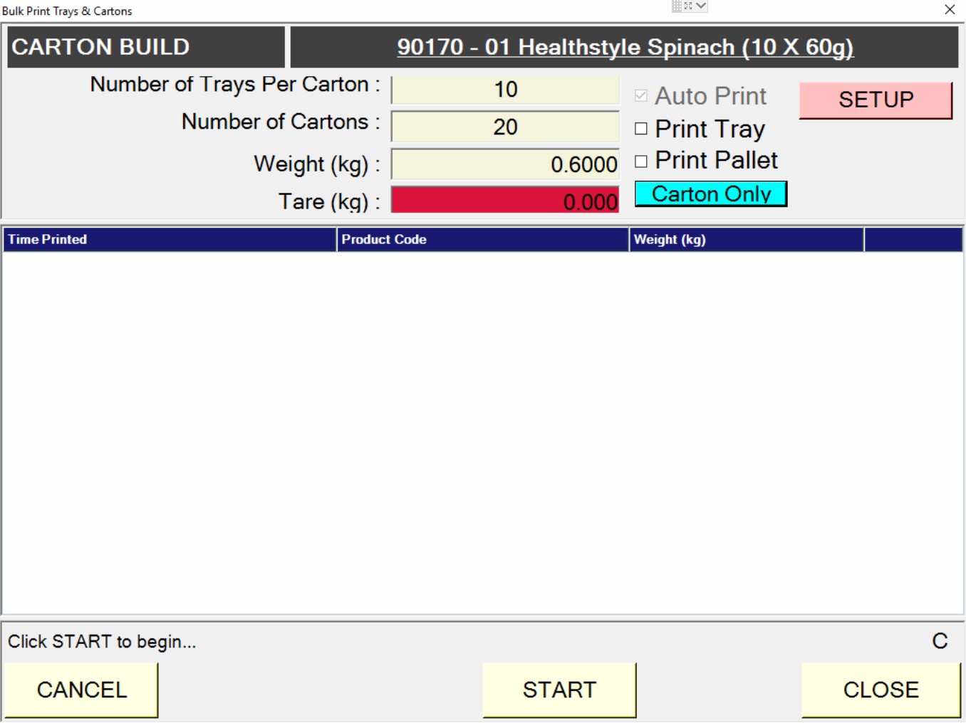

3.5 Order Picking

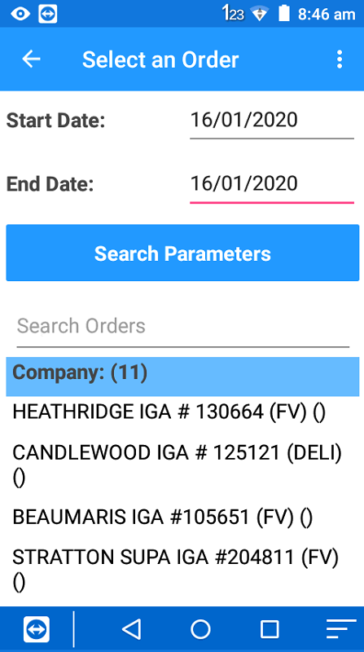
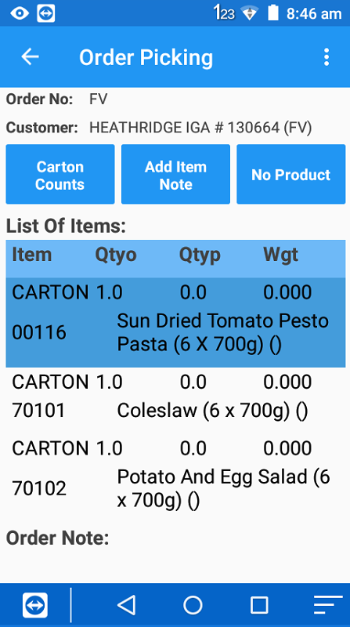
The Plant Control System has order picking capabilities using Mobile Computers or Touch screens with wireless scanners as seen on screens hots below.

This process creates accuracy by preventing scanning the wrong products, make sure min shelf life conditions per customers is maintained, and preventing selecting products tat already picked and sold to other customers.

All the serial numbers for products picked for order are maintained in the system for full traceability.

Customer Label for Building Pallets are also generated as per pictures below, this is to make the delivery process more accurate and faster.

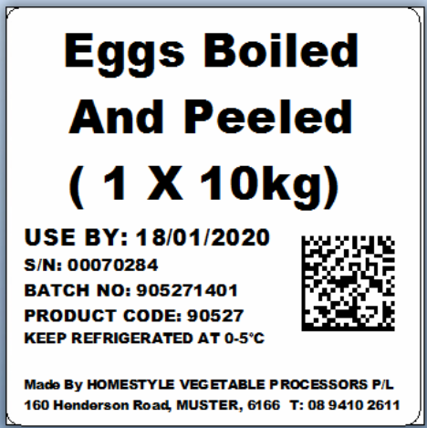
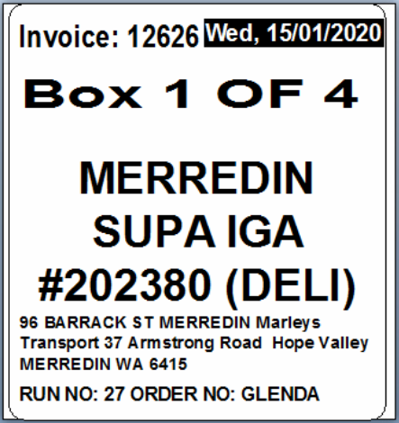
Product Label
Customer Label
The following screens shows the picking screen on the Touch screen used with the wireless barcode scanner to can cartons to orders.
On the left are the orders for a date range, and on the right are the individual products required to be picked.
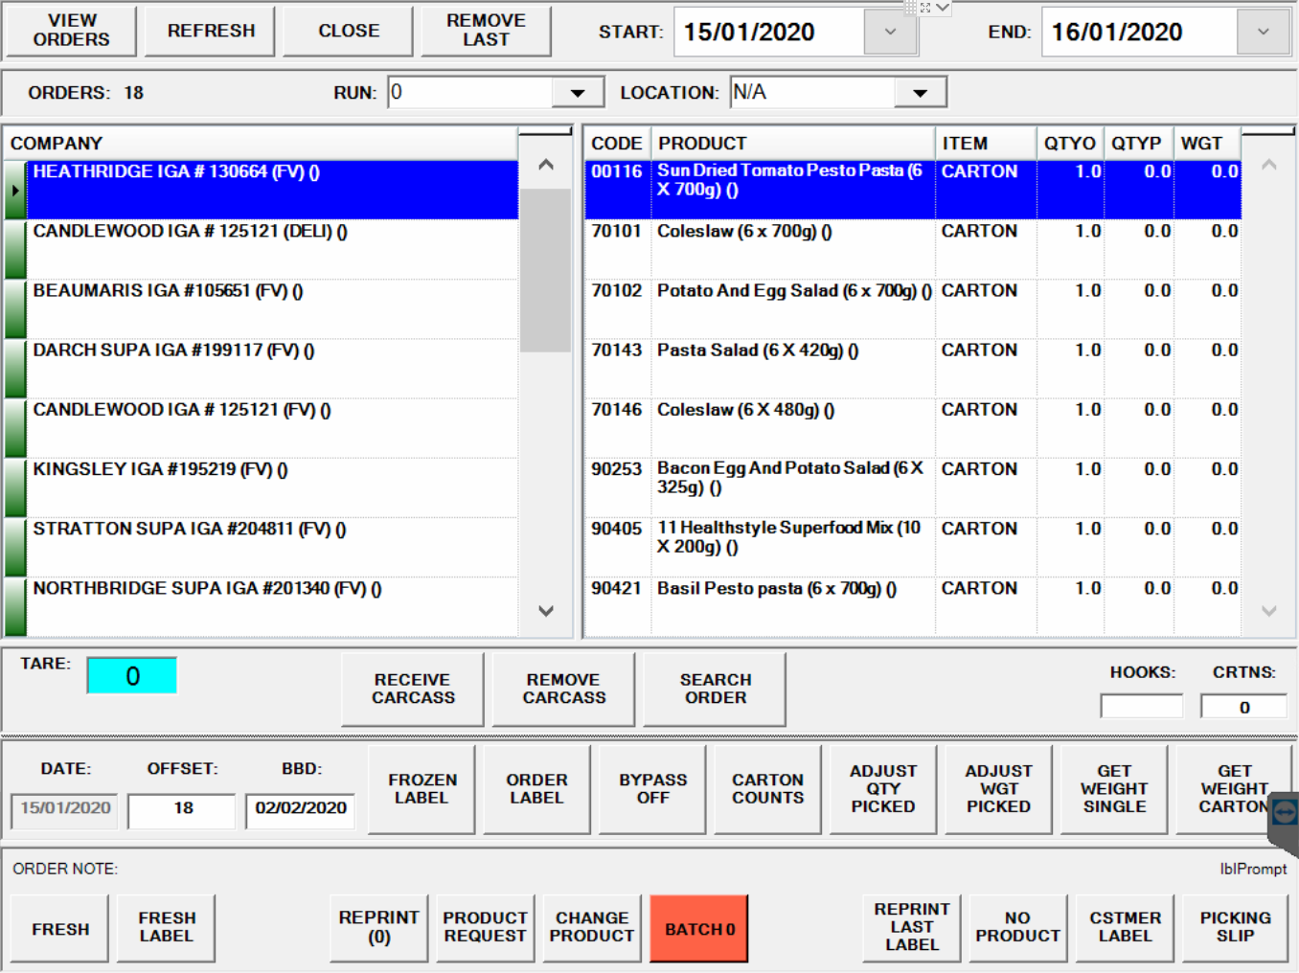

The following screen shots shows the orders entered and picked information with serial number counts and weight for each product.
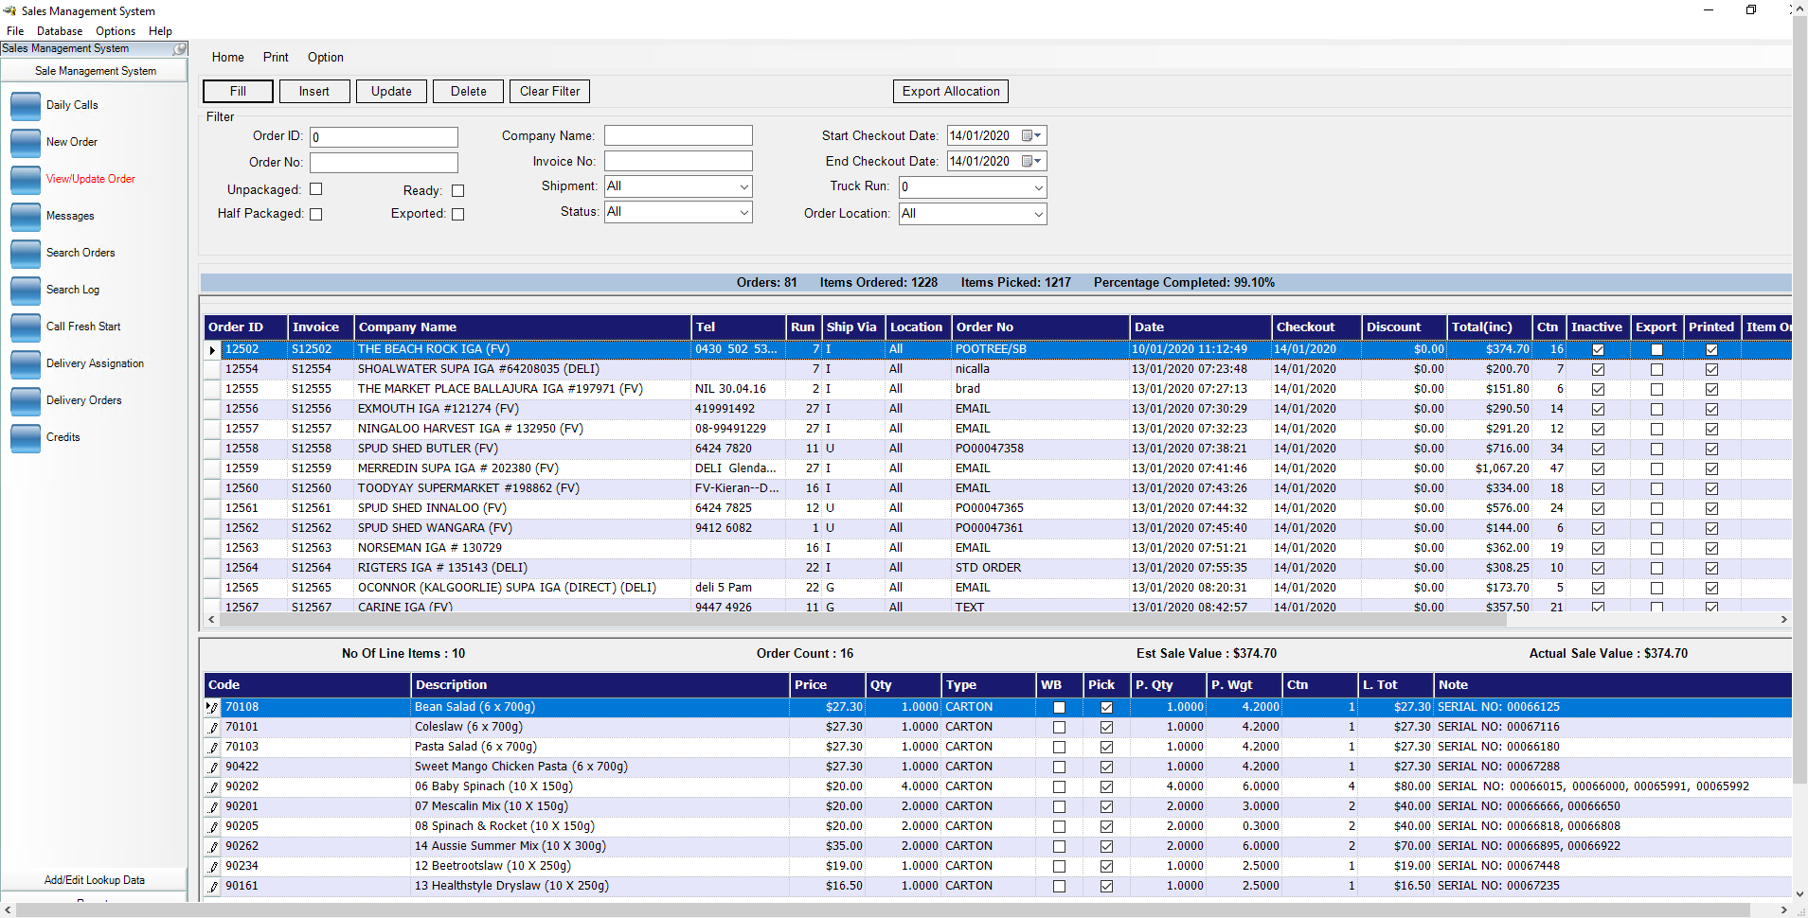
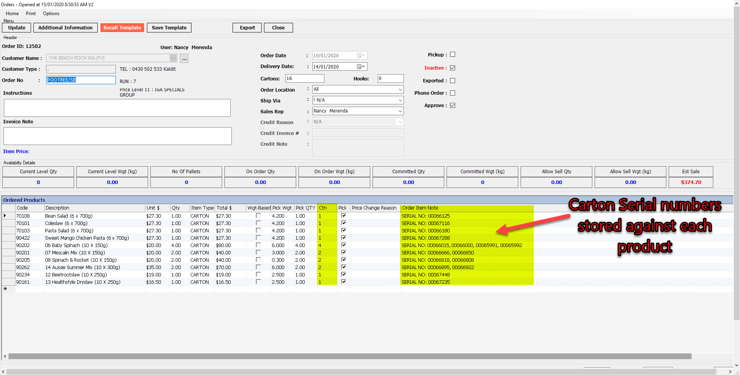

Appendixes

Appendix A – GS1-128 System and Barcodes

