MINISFORUM MS-A2
Specification
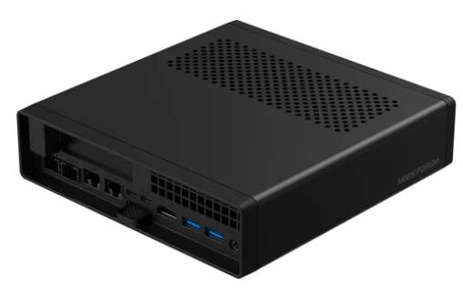
CPU
AMD Ryzen™ 9 9955HX
GPU
AMD Radeon™ 610M
Memory
Up to 96GB DDR5 (SO-DIMM х2)
- Ryzen 9000 Series: DDR5 (SO-DIMM х 2),up to 5600Mhz
Up to 96GB DDR5 (SO-DIMM х2)
- Ryzen 7000 Series: DDR5 (SO-DIMM х 2),up to 5200Mhz
Storage
- M.2 2280/U.2NVME SSD *1 (Up to 15TB/ 7mm thick)(PCIe 4.0x4)(OnBoard)
- M.2 2280/22110NVME(Up to 4TB)(PCIe 4.0x4)
Wireless Connectivity
M.2 2230 E-Key (Wi-Fi 6E & Bluetooth® 5.2)
Screen&Sensor
N/A
Video Output
- HDMI2.1 x1 (Up to 8K@60Hz)
- Type-C(Alt DP2.0) x 2(Up to 8K@60Hz/4K@144Hz)
Audio Output
- HDMI х 1
- Type-C x 2
- 3.5mm Combo Jack 4 in 1 х 1
Audio Input
3.5mm Combo Jack 4 in 1 х 1
Front I/O Ports
- 3.5mm Comble Audio Jack 4 in 1 х 1
- USB Type A(USB3.2 Gen1) х 2
- USB Type A(USB2) х 1

Back I/O Ports
- Type-C(USB3.2 Gen2 10Gbps)(Alt DP2.0) x 2
- HDMI2.1 х 1
- 2.5 LAN(RJ45)(Intel RTL8125) х 1
- 2.5 LAN(RJ45)(Intel I226-V) х 1
- 10G SFP+(Intel X710) x 2
- USB Type A(USB3.2 Gen2) х 1
- USB Type A(USB3.2 Gen1) х 1
PCIE Expansion
PCIEx16 (PCIE4.0x8)
Fan
- FAN For CPU x 1(12V)
- FAN For SSD x 1(5V)
Button/Hole/LED
- Power Button With LED(White) х 1
- Reset Hole х 1
Power Adapter
19V/12.63A
OS Support
Windows 11/Linux
Product Dimension
196×189×48mm

