MINISFORUM MS-02-Ultra
Specification
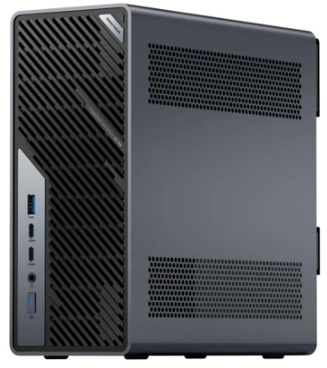
CPU
Intel® Core™ Ultra 9 285HX
24 Cores (8 P-Cores + 16 E-Cores), 24 Threads
Max Clock: 5.5 GHz
TDP
Without dGPU: 100W PL1 / 140W PL2
With dGPU: 90W PL1 / 110W PL2
GPU
Intel® Graphics(Internal)
Max GPU Clock: 2 GHz
AI Engine Performance
Intel® AI
NPU Computing Power: Up to 13 TOPS
RAM
4 x DDR5 SODIMM slots​ (ECC supported; XMP overclocking not supported).
Max frequency support: 4800MHz
Max capacity support: 256GB
SSD
2 × M.2 2280 NVMe SSD slots
(PCIe 4.0 x4, Up to 8TB each)
2 × M.2 2280 NVMe SSD slots
(Inside 25GbE NIC, up to 8 TB/slot PCIe 3.0 x4) or 4 TB/slot PCIe 4.0 x4)
Heat Dissipation
Six-heatpipe radiator with Phase Change Material (PCM)
Max CPU Fan Speed: 5000 RPM
Wireless Connectivity
Wi-Fi 7 | Bluetooth® 5.4
Ethernet Controller
2 × 25 GbE SFP+
1 × 10 GbE LAN RJ45
1 × 2.5 GbE LAN RJ45
Video Output
​1 x HDMI™ 2.1 FRL​ (8K@60Hz, 4K@120Hz)
​1 x USB4 with DP Alt Mode​ (8K@60Hz, 4K@120Hz)
​2 x USB4 V2 with DP Alt Mode​ (8K@60Hz, 4K@120Hz)

Audio Output
1 х HDMI™
1 х USB4
2 х USB4 V2
1 х 3.5mm Audio Jack
Audio Input
3.5mm Combo Jack（TRRS） х 1
I/O Ports (Front)
​2 x USB4 V2 Type-C Ports​(80 Gbps, DP 2.0 Alt Mode, 15W PD)​
1 x USB 10Gbps Type-A Port​(USB 3.2 Gen 2)​
1 x 3.5mm Audio Jack
​​1 x Power Button
I/O Ports (Rear)
2 x 25GbE SFP+ Ports (Intel E810)
1 x 10GbE RJ45 Port (Realtek RTL8127)
1 x 2.5GbE RJ45 Port (Intel I226-LM, vPro Enabled)
1 × HDMI™ 2.1 FRL
​1 x USB4 Type-C Port​(40 Gbps, DP 2.0 Alt Mode, 15W PD)
3 x USB-A 10Gbps(USB 3.2 Gen 2)
I/O Ports (Internal)
1 × PCIe ​5.0 x16 Slot (bifurcation support )
1 × PCIe ​4.0 x16 Slot​ (PCIe ​4.0 x4+x4+x4) ​with​ Pre-installed 25GbE NIC
1 × PCIe ​4.0 x4 Slot
Button/Hole
Clear CMOS Button x 1
Pre-installed OSOS Support
Windows 11 Pro
Power
AC input (100-240V ~6A 50-60Hz, 1U 350W MAX)
VESA Mount & Dimensions
N/A
Weight
3.45 kg

