Android 9.0 IP67 Rugged UHF/Barcode/Infrared Android Tablet (LP-007)

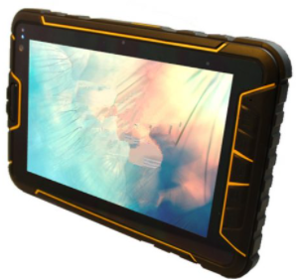
Overview
The industrial IP67 PDA utilizes advanced technology and provides powerful functions with reliable performance.
This industrial PDA adopts Qualcomm Snapdragon 450 platform, Octa core 1.8 GHz CPU and Android 9.0 operation system and can configure barcode scanning, RFID reader, fingerprint identification as well as other information acquisition module. It utilizes advanced technology and provides powerful function and reliable performance. The PDA adopts the combination of host and modular jacket design concept. It not only has intelligent operation platform but also has functional modular jacket with flexible configuration. So it can satisfy the customized requirements from different industries.
The Android PDA features super long battery life, IP67 high reliable three-proof structure, drop resistance and LCD screen readable under sunlight. the Android Tablet is ideal for employees across a range of industries, including mobile field services, logistics, warehousing, transportation, manufacturing, fleet management and more. Its impressive flexibility enables you to supply one device to meet many requirements; and it is built to be a key member of your IT infrastructure.

Key Features
• Advanced system: Android 9.0 os operating system; Octa core 1.8GHz CPU; RAM 4GB,ROM64GB
• Three-proof design: IP67 three protection grade, drop resistance from 1.2m
• Visible under strong light: 7 inch LCD screen, 1280×800 IPS capacitive touch screen
• Powerful function: multi functions data acquisition configuration (1D/2D bar code scanning, LF/HF/UHF RFID reader, fingerprint identification)
• Multi communication modes: wireless communication 4G, WIFI, Bluetooth etc.
• Super long life: 7200mA, more than 600 hours of continuous standby
• Light weight: 590g only

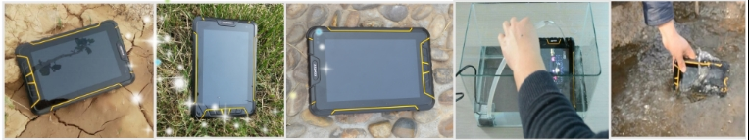

Technical Data:

General Specifications
Model NO. | LP-007
Operating System | Android 9.0 OS
CPU | Qualcomm SDM450 Octa core CPU, 1.8GHz
RAM | RAM: 4G
RAM | FLASH: 64G
Extended Storage | Micro SD, Maximum 128G
USB port | 5 pin MicroUSB; support OTG (U-disk/Mouse/Keyboard/USB Ethernet cable)
OTG | Support, through OTG can meet 100M network port, network card setup, PPPoE dial-up, web browsing. Support OTG extend RS232 serial port
External port | Charge port, headphone port

Protection Grade
Industrial Protection Grade | IP67
Drop Grade | Drop resistance from 1.2m
Wireless Communication
Bluetooth | Support 4.2
GPS | Support GPS, DBS, GLONASS and professional GPS,Ublox;  GPS and Beidou (alternative)
WIFI | Support IEEE 802.11a/b/g/n/ac 2.4G+5G dual band
Band | Band Version 1(North America version)
Band | LTE-FDD:B2/B4/B5/B7/B12/B13/B14/B25/B26  LTE-TDD:B41  WCDMA:B1/B2/B5/B8  GSM:850/900/1800/1900M
Band | Band Version 2(China and Europe verison)
Band | LTE-FDD:B1/B3/B5/B8  LTE-TDD:B34/B38/B39/B40/B41  WCDMA:B1/B8 TD-SCDMA:B34/B39  CDMA:BC0 GSM:900/1800M

Data Acquisition (Optional)
Fingerprint identification | Supports fingerprint entry, image collection, fingerprint recognition, fingerprint deletion etc.
Fingerprint identification | Type | TCSIST semiconductor sensor
Fingerprint identification | ISO Template | Support
Fingerprint identification | Sensor type | Capacitive
Fingerprint identification | Acquisition window size | 24.5*19MM
Fingerprint identification | Effective image size | 15.5*18.5MM
Fingerprint identification | Image Size | 256*360 Pixels
Fingerprint identification | Image Resolution | 500DPI
Fingerprint identification | Matching mode | contrast mode(1:1); search mode(1:N)
Far infrared meter reading | Working frequency 37.9K
 | Internal 1D Infrared Scanner: Zebra SE655
 | Scanning speed: 50 times/second
 | Scanning distance: 5.7cm-61.0cm
 | Scanning angle: 53.3° ±3°
Barcode Scanning | External 1D Laser Scanner: Honeywell N4313 Zebra EM1350
 | Scanning speed: 104 times/second+12 times/second (two way scanning)
 | Scanning distance: 2.5cm-114.3cm
 | Scanning angle: 47±3°(default) /35±3°(reduced code)
 | 2D Barcode Scanner : Internal Honeywell N6603 2D laser or External Newland NLS-EM3296
 | Identification ability: 1D, 2D, OCR
 | Scanning angle: rotate 360°, incline±50°, deflection ±50°
 | Field of View: Horizontal 36°, vertical 23°
 | Depth of field: 4cm-23.5cm
 | Environmental luminance: 0~100,000 LUX
RFID | LF RFID:
RFID | 134KHZ LF RFID or 125KHZ LF RFID
RFID | NFC (HF) RFID:
RFID | Working frequency: 13.56MHZ
RFID | Profile: Support ISO/IEC 15693, ISO/IEC 14443A profile
RFID | Support Cards: SR176, SRIX4K (TYPE-B), I- Code2, TI RFID label-it HF-I, EM4034, Mifare Classic ETC
RFID | Identification distance: not more than 5cm
RFID | UHF RFID:
RFID | Working frequency: 840-960MHz(customization of required frequency band)
RFID | Support agreement: EPC C1 GEN2/ISO 18000-6C
RFID | Output power: 10dBm-30dBm
RFID | Identification distance: not more than 6m  ImpinjR2000 chipset

Physical Parameters
Display Screen | 7 inch LCD screen, 1280×800 IPS screen, capacitive touch screen
Keyboard | Android menu, Homepage, Return, Volume, Barcode, ON/OFF, Reset
Camera5 | million pixels front camera, 13 million pixels rear camera  with automatic focus and lighting functionn
Headset | 3.5mm audio Interface, has mike and telephone receiver
LED indicator light | Support (ordinary flicker, Call fast flicker, missed calls) three status bar
Flashlight Function | Support, can be used for emergency lighting
Googleplay store | Support
Gravity sensor | Support
Compass | Support
Vibrating motor | Support
FM | Support
Rechargeable  Lithium Battery | 3.7V, 7200mAh
Standby | Standby current less than 10mA
Dimension | 209mm*139mm*19mm
Weight | 590g

Environmental Characteristics
Working Temperature | -20℃ ~50℃
Storage Temperature | -40℃ ~60℃
Humidity | 5%-95% relative humidity; no condensation

